**Filtro BP Elíptico**

|  |  |
| --- | --- |
| **Quantizado 20 bits Forma direta II Second-Order Sections** | |
| --------------------------  Section #1  --------------------------  Quantized Numerator:  1  0.447238922119140625  1  Quantized Denominator:  1  0.609889984130859375  0.959873199462890625  Quantized Gain:  0.0974700450897216796875  --------------------------  Section #2  --------------------------  Quantized Numerator:  1  0.916660308837890625  1  Quantized Denominator:  1  0.74639129638671875  0.960933685302734375  Quantized Gain:  1  --------------------------  Quantized Output Gain:  1 | --------------------------  Section #1  --------------------------  Reference Numerator:  1  0.447238317791046668947529951765318401158  0.999999999999998001598555674718227237463  Reference Denominator:  1  0.609889161544318381125151518062921240926  0.959873294530185661166399313515285030007  Reference Gain:  0.097470123833690330839019111408561002463  --------------------------  Section #2  --------------------------  Reference Numerator:  1  0.916660471787325237258414745156187564135  1.000000000000003108624468950438313186169  Reference Denominator:  1  0.746392789923348010105996763741131871939  0.960933982016556109684302100504282861948  Reference Gain:  1  --------------------------  Reference Output Gain:  1 |

|  |  |
| --- | --- |
| **Comparativo** | |
| Discrete-Time IIR Filter (real)  -------------------------------  Filter Structure : Direct-Form II  Numerator Length : 5  Denominator Length : 5  Stable : Yes  Linear Phase : No  Arithmetic : fixed  Numerator : s20,21 -> [-2.500000e-01 2.500000e-01)  Denominator : s20,17 -> [-4 4)  Input : s16,15 -> [-1 1)  Output : s27,24 -> [-4 4)  State : s16,15 -> [-1 1)  Numerator Prod : s36,36 -> [-5.000000e-01 5.000000e-01)  Denominator Prod : s36,32 -> [-8 8)  Numerator Accum : s39,36 -> [-4 4)  Denominator Accum : s39,32 -> [-64 64)  Round Mode : convergent  Overflow Mode : wrap    Implementation Cost  Number of Multipliers : 9  Number of Adders : 8  Number of States : 4  Multiplications per Input Sample : 9  Additions per Input Sample : 8 | Discrete-Time IIR Filter (real)  -------------------------------  Filter Structure : Direct-Form II, Second-Order Sections  Number of Sections : 2  Stable : Yes  Linear Phase : No  Arithmetic : fixed  Numerator : s20,18 -> [-2 2)  Denominator : s20,18 -> [-2 2)  Scale Values : s20,22 -> [-1.250000e-01 1.250000e-01)  Input : s16,15 -> [-1 1)  Section Input : s16,13 -> [-4 4)  Section Output : s16,11 -> [-16 16)  Output : s27,22 -> [-16 16)  State : s16,15 -> [-1 1)  Numerator Prod : s36,33 -> [-4 4)  Denominator Prod : s36,33 -> [-4 4)  Numerator Accum : s38,33 -> [-16 16)  Denominator Accum : s38,33 -> [-16 16)  Round Mode : convergent  Overflow Mode : wrap    Implementation Cost  Number of Multipliers : 9  Number of Adders : 8  Number of States : 4  Multiplications per Input Sample : 9  Additions per Input Sample : 8 |

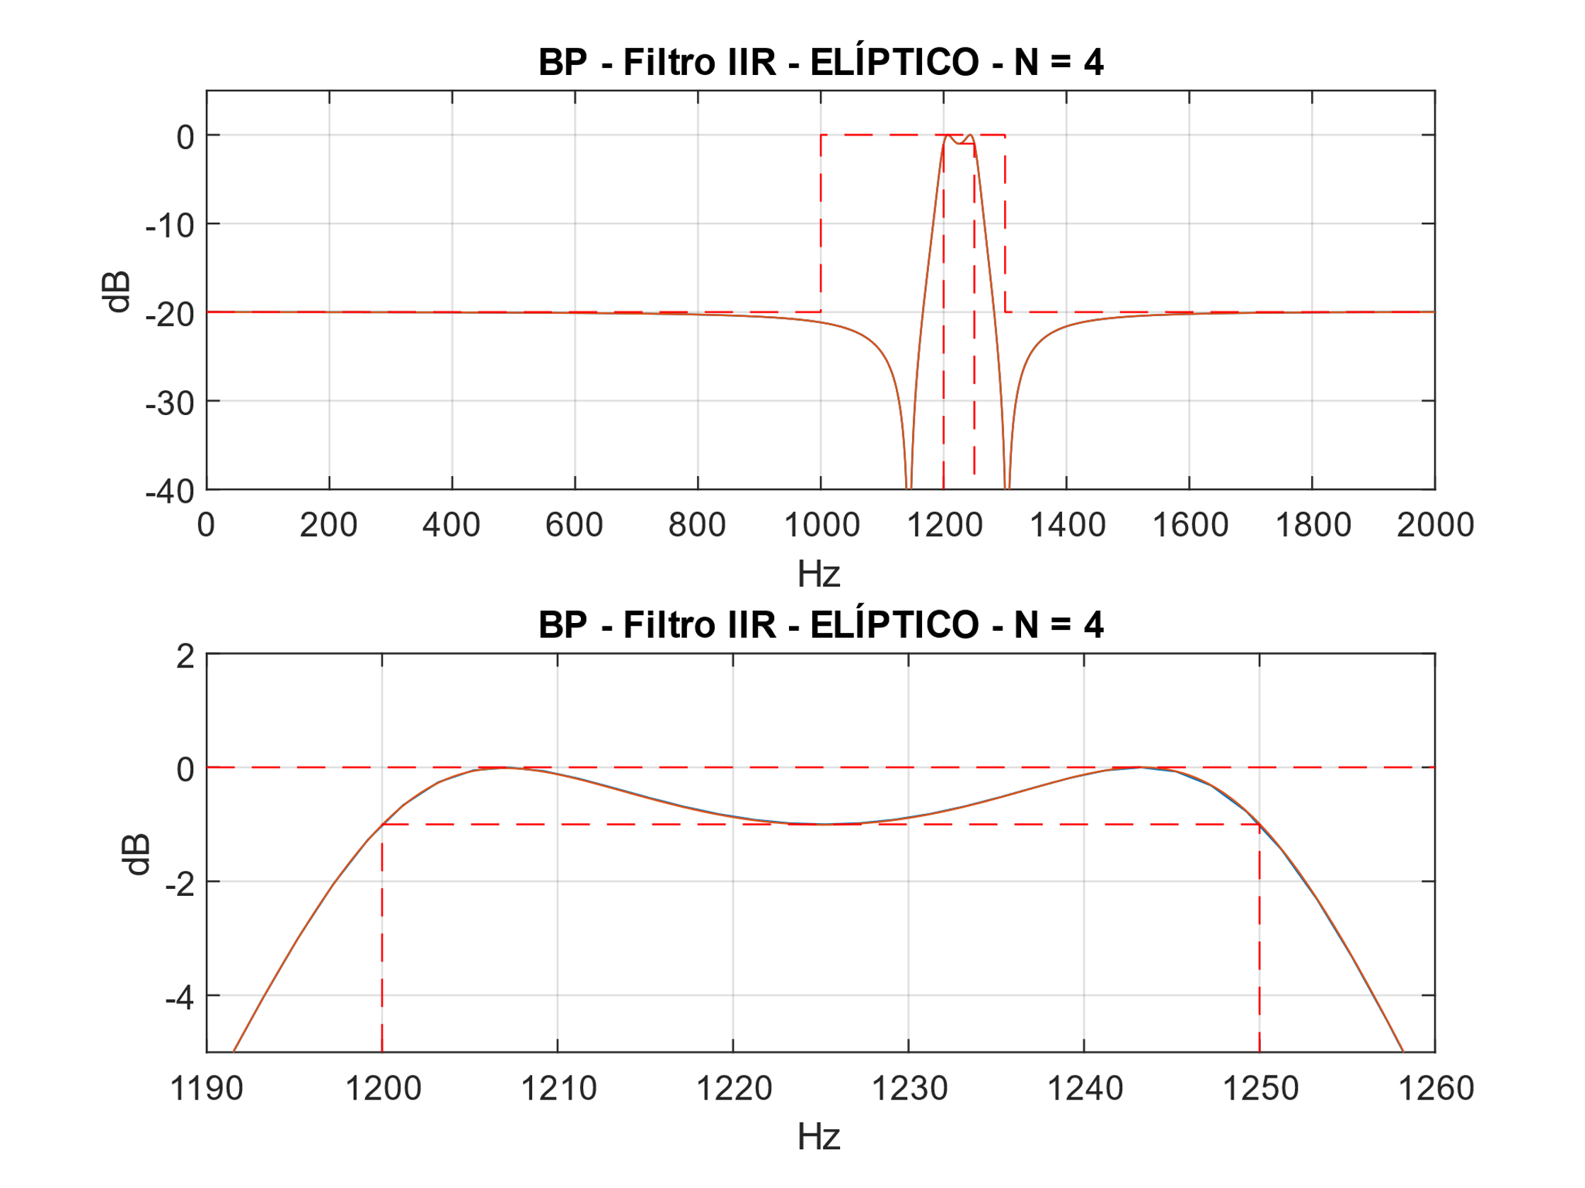

Figura 1 - Filtro DFII

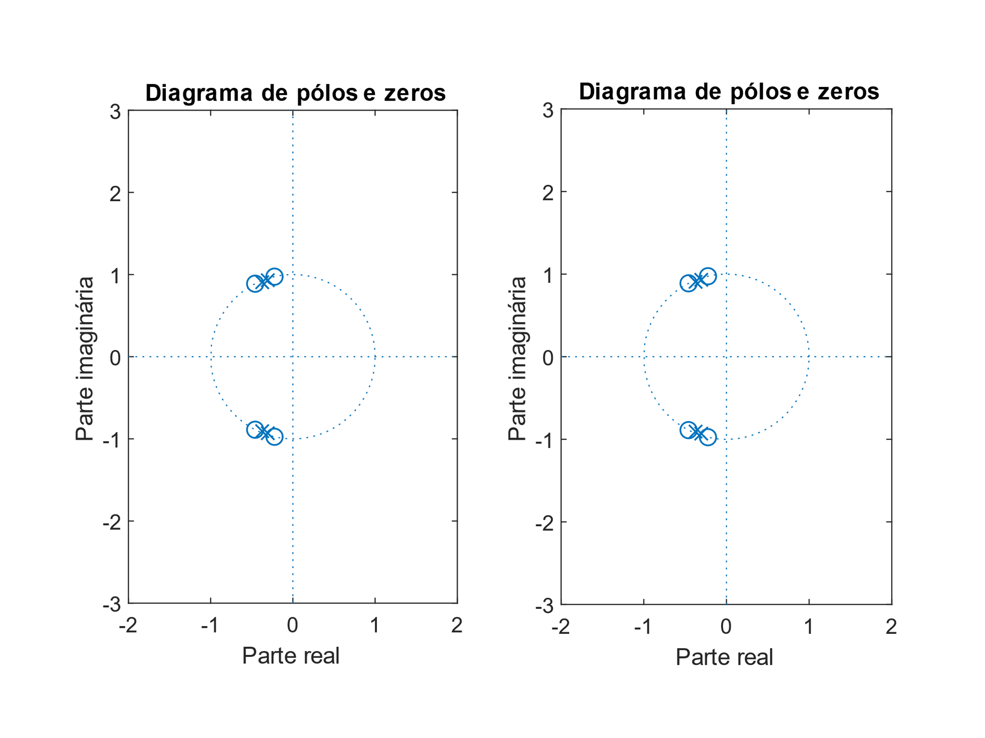

Figura 2 - Filtro DFII

ASIC:

(2M + S + D) * nº bits

(2 * 9 + 8 + 4) * 20 = 600 elementos

FPGA:

(2M + S) * nº bits

(2 * 9 + 8) * 20 = 520 elementos

**Filtro BP PM**

|  |  |
| --- | --- |
| **Quantized Numerator 8bits** | **Reference Numerator** |
| -0.04296875  0.00390625  0.00390625  0.00390625  0.0048828125  -0.0009765625  0.001953125  0.0126953125  -0.001953125  -0.0107421875  0.0166015625  0.0126953125  -0.01953125  0.0009765625  0.0263671875  -0.0078125  -0.015625  0.0185546875  0.0087890625  -0.009765625  0.001953125  0.001953125  0.005859375  0.0146484375  -0.0205078125  -0.0107421875  0.0478515625  -0.0048828125  -0.0615234375  0.044921875  0.060546875  -0.0810546875  -0.0263671875  0.1103515625  -0.0205078125  -0.1044921875  0.07421875  0.07421875  -0.1044921875  -0.0205078125  0.1103515625  -0.0263671875  -0.0810546875  0.060546875  0.044921875  -0.0615234375  -0.0048828125  0.0478515625  -0.0107421875  -0.0205078125  0.0146484375  0.005859375  0.001953125  0.001953125  -0.009765625  0.0087890625  0.0185546875  -0.015625  -0.0078125  0.0263671875  0.0009765625  -0.01953125  0.0126953125  0.0166015625  -0.0107421875  -0.001953125  0.0126953125  0.001953125  -0.0009765625  0.0048828125  0.00390625  0.00390625  0.00390625  -0.04296875 | -0.043341209293729365814584753024973906577  0.004281253812653358289952443271886295406  0.004335494878364479741372772281238212599  0.00392877576103001918683688131750386674  0.004736726505523391507479491480125943781  -0.001135367477393670792087942977843795234  0.002256640878714070985733286534014041536  0.012984535801807655167050548072893434437  -0.001616721999504678892317643956744177558  -0.010460401079357159112581676652098394698  0.016318555880486765308212682157318340614  0.012820038339943537475384971457970095798  -0.019581101591675250522817108844719768967  0.001394593561952460871247727602906252287  0.026590862891752109486986910269479267299  -0.008018158482333585454493452004953724099  -0.015984685328886534538828101403851178475  0.01828791026618866236153060356173227774  0.009170686991115204605984345676006341819  -0.010157194607374261594023856503099523252  0.002133679320782085660906934876379636989  0.001469793261490869376584278427344543161  0.005845520686809042680553982762603482115  0.014273641267823123160440879075849807123  -0.020343580794634545660937163802373106591  -0.010935970975377289071683861720885033719  0.048172998657642573938630903285229578614  -0.005095924953120942353657074619377453928  -0.061726270772076742565648288518787012435  0.04457563278596876621406863705487921834  0.06038306610053461448428535618404566776  -0.081431920664949211663419248452555621043  -0.026284446547936522048383167771135049406  0.110018542760450824258278146317024948075  -0.020620031074709790908094930728111648932  -0.104385583334049819592692642800102476031  0.074660880022621889384737414729897864163  0.074660880022621889384737414729897864163  -0.104385583334049819592692642800102476031  -0.020620031074709790908094930728111648932  0.110018542760450824258278146317024948075  -0.026284446547936522048383167771135049406  -0.081431920664949211663419248452555621043  0.06038306610053461448428535618404566776  0.04457563278596876621406863705487921834  -0.061726270772076742565648288518787012435  -0.005095924953120942353657074619377453928  0.048172998657642573938630903285229578614  -0.010935970975377289071683861720885033719  -0.020343580794634545660937163802373106591  0.014273641267823123160440879075849807123  0.005845520686809042680553982762603482115  0.001469793261490869376584278427344543161  0.002133679320782085660906934876379636989  -0.010157194607374261594023856503099523252  0.009170686991115204605984345676006341819  0.01828791026618866236153060356173227774  -0.015984685328886534538828101403851178475  -0.008018158482333585454493452004953724099  0.026590862891752109486986910269479267299  0.001394593561952460871247727602906252287  -0.019581101591675250522817108844719768967  0.012820038339943537475384971457970095798  0.016318555880486765308212682157318340614  -0.010460401079357159112581676652098394698  -0.001616721999504678892317643956744177558  0.012984535801807655167050548072893434437  0.002256640878714070985733286534014041536  -0.001135367477393670792087942977843795234  0.004736726505523391507479491480125943781  0.00392877576103001918683688131750386674  0.004335494878364479741372772281238212599  0.004281253812653358289952443271886295406  -0.043341209293729365814584753024973906577 |

|  |  |
| --- | --- |
| **Comparativo** | |
| Discrete-Time FIR Filter (real)  -------------------------------  Filter Structure : Direct-Form Symmetric FIR  Filter Length : 74  Stable : Yes  Linear Phase : Yes (Type 2)  Arithmetic : fixed  Numerator : s8,10 -> [-1.250000e-01 1.250000e-01)  Input : s16,15 -> [-1 1)  Filter Internals : Full Precision  Output : s27,25 -> [-2 2) (auto determined)  Tap Sum : s17,15 -> [-2 2) (auto determined)  Product : s24,25 -> [-2.500000e-01 2.500000e-01) (auto determined)  Accumulator : s27,25 -> [-2 2) (auto determined)  Round Mode : No rounding  Overflow Mode : No overflow    Implementation Cost  Number of Multipliers : 37  Number of Adders : 73  Number of States : 73  Multiplications per Input Sample : 37  Additions per Input Sample : 73 | Discrete-Time FIR Filter (real)  -------------------------------  Filter Structure : Direct-Form FIR Transposed  Filter Length : 74  Stable : Yes  Linear Phase : Yes (Type 2)  Arithmetic : fixed  Numerator : s8,10 -> [-1.250000e-01 1.250000e-01)  Input : s16,15 -> [-1 1)  Filter Internals : Full Precision  Output : s27,25 -> [-2 2) (auto determined)  States : s27,25 -> [-2 2) (auto determined)  Product : s23,25 -> [-1.250000e-01 1.250000e-01) (auto determined)  Accumulator : s27,25 -> [-2 2) (auto determined)  Round Mode : No rounding  Overflow Mode : No overflow    Implementation Cost  Number of Multipliers : 74  Number of Adders : 73  Number of States : 73  Multiplications per Input Sample : 74  Additions per Input Sample : 73 |

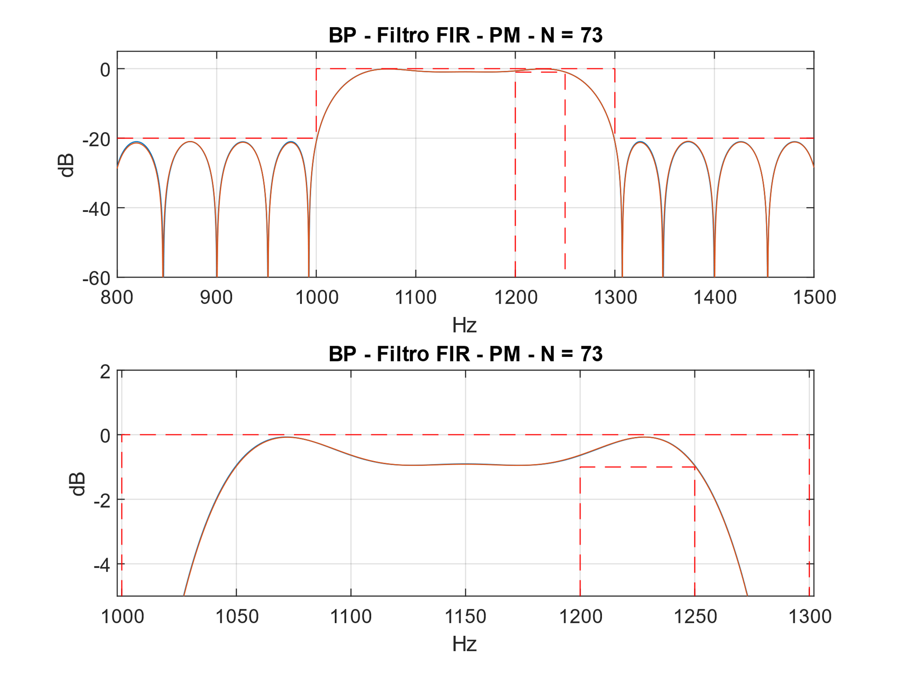

Figura 3 - Filtro DF Symmetric.

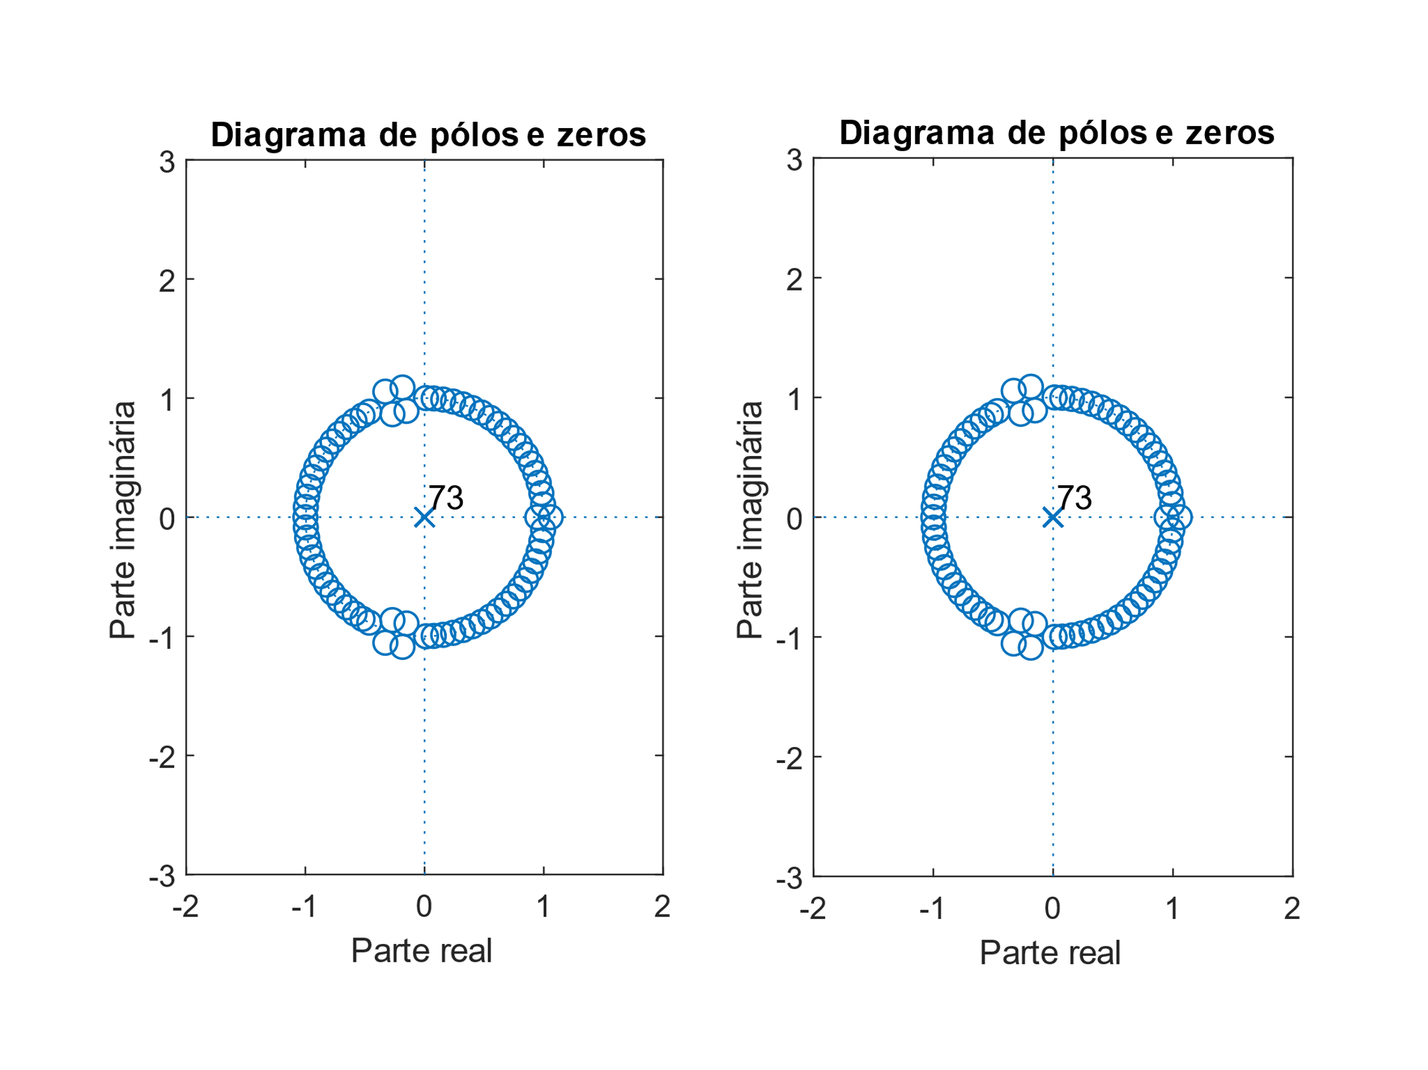

Figura 4 - Filtro DF Symmetric.

ASIC:

(2M + S + D) * nº bits

(2 * 37 + 73 + 73) * 8 = 1760 elementos

FPGA:

(2M + S) * nº bits

(2 * 37 + 73) * 8 = 1176 elementos